Netrin gradients Cues on Receptors
Name of Student
Name of Institution
Date
Netrin Gradients Cues on Receptors
In a mutagenic screen, a postdoc found that knocking out a fly gene caused developing axons to not respond to many common guidance cues like netrins, BDNF, etc. Because these axons seem to grow randomly and roam throughout the fly embryo, she named the gene Zombie. One such example of failure to respond to axon guidance cues was Netrin, a common attractant for dorsal commissural neurons. When wild type neurons are exposed to a netrin gradient, they growth cone responds by turning in the direction of the netrin source. Zombie knock outs do not seem to respond to any source of netrin. See below:
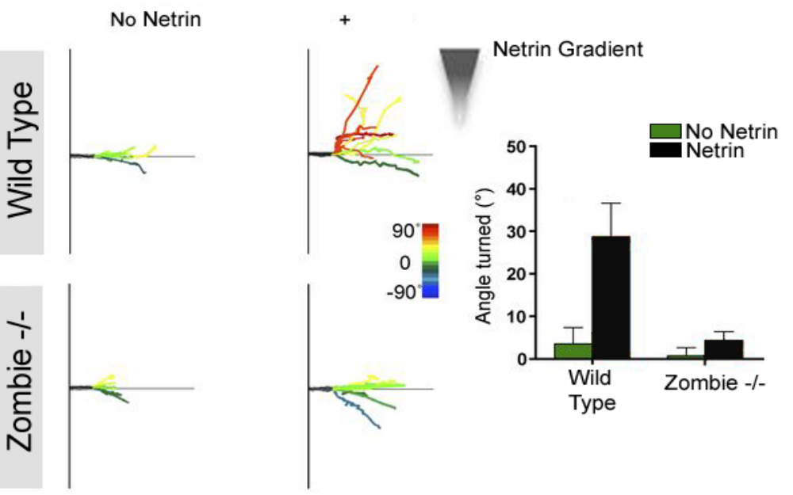
- In her haste, the postdoc never verified where in the genome the zombie mutation was located. Meaning, she has no idea if this is a new gene. Based on the information above, is it likely that the mutated Zombie gene is a netrin receptor? Why or why not?
The mutated zombie gene is not a netrin receptor. Netrin receptors sense the presence on netrin gradients from whichever direction, and the extreme nib of the axon shifts on the shooting molecules to cone towards that extremity. The actuated shootin1a stimulate interactivity betwixt the internal skeleton and L1-CAM, which effectively aid the axon to curve in the direction of the netrin gradient (Baba, et al., 2018). In other instances, shootin1a is present on every part of the axon, not just the tips, and thus it develops towards the netrin gradient rather than turning. The mutated zombie gene does not exhibit any of the above characteristics and thus does not qualify as a netrin receptor.
- The postdoc’s PI suggested that the Zombie gene product may be involved in protein translation of local actin that helps the growth cone alter course when presented with a new guidance cue. The postdoc thinks that the Zombie protein helps traffic receptors for guidance cues to the membrane of the growth cone. Design an experiment that either confirms or disproves one of these positions.
A microfluidic device that generates netrin-1 gradients in culture medium was produced following prior findings that had been customized. For a brief moment it was forged with polydimethylsiloxane and thin sheets of glass; the appliance was composed of an unlatched orthogonal cell culture zone and 2 micro-channels aligned along the long sides. The micro-molds were lithographically forged on a photo-resistant wide silicon wafer. The mold was the source of the PDMS sheets after treatment with silicone oil to enable extraction. A PDMS sheet, coated with glue, was connected to a thin sheet of glass slip coated with polylysine and L1-CAM-Fc. To produce netrin gradients, flows of culture medium, consistent of or lacking fluorescent tracers, were exerted to the micro-channels on both sides of the culture area. The axon turning to the source of netrin required calculations of the subtraction of the angles of the nib from the initial and final points, with regulation and measurements of time-points (Bhattacharjee, Li, Keenan, & Folch, 2010).

References
Baba, K., Yoshida, W., Toriyama, M., Shimada, T., Manning, C. F., Saito, M., . . . Inagaki, K. (2018). "Gradient-reading and mechano-effector machinery for netrin-1-induced axon guidance.". eLife 7, e34593. Retrived from https://cdn.elifesciences.org/articles/34593/elife-34593-v1.pdf
Bhattacharjee, N., Li, N., Keenan, T. M., & Folch, A. (2010, October 19). "A neuron-benign microfluidic gradient generator for studying the response of mammalian neurons towards axon guidance factors.". Integrative Biology, 2(11-12), 669-670. Retrieved from https://academic.oup.com/ib/article-abstract/2/11-12/669/5212772

